## Name: Laura C. Larregui Date: February 16, 2020

## Lab 06 – Querying, Inserting, Updating, and Deleting

Part 1 – Filling Our Tables with Data

1. First VidCast
2. Saul’s First VidCast



1. Update a User

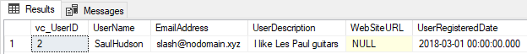

1. No More On Time

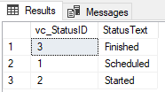

Part 2 – Putting All Together

1. Tags

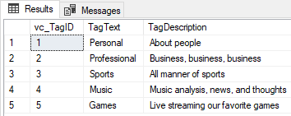

SELECT * FROM vc_Tag

INSERT INTO vc_Tag

(TagText, TagDescription)

VALUES

('Personal', 'About people'),

('Professional','Business, business, business'),

('Sports','All manner of sports'),

('Music','Music analysis, news, and thoughts'),

('Games','Live streaming our favorite games')

SELECT * FROM vc_Tag

1. Users

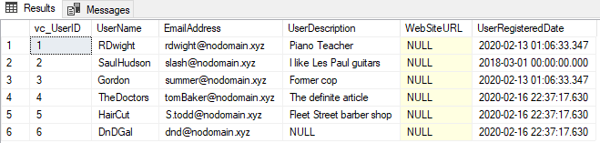

SELECT * FROM vc_User

INSERT INTO vc_User

(UserName, EmailAddress, UserDescription)

VALUES

('TheDoctors', 'tomBaker@nodomain.xyz', 'The definite article'),

('HairCut', 'S.todd@nodomain.xyz', 'Fleet Street barber shop'),

('DnDGal', 'dnd@nodomain.xyz', 'NULL')

SELECT * FROM vc_User

1. User Tag List

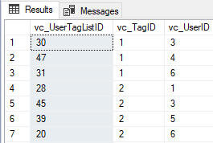

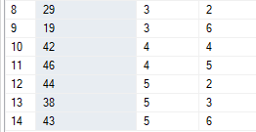

1. User Tags Report

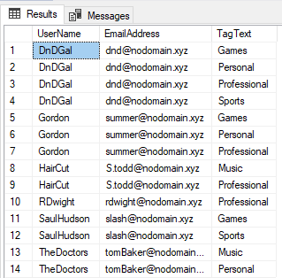

SELECT

vc_User.UserName,

vc_User.EmailAddress,

vc_Tag.TagText

FROM vc_UserTagList

JOIN vc_User ON vc_UserTagList.vc_UserID=vc_User.vc_UserID

JOIN vc_Tag ON vc_UserTagList.vc_TagID=vc_Tag.vc_TagID

ORDER BY vc_User.UserName, vc_Tag.TagText

# Query Text File for Lab 6

--Adding a row to the vc_Status table

INSERT INTO vc_Status(StatusText)

VALUES ('Scheduled')

-- The following line shows all the rows of vc_Status

SELECT * FROM vc_Status

--Adding three more values to the vc_Status table

INSERT INTO vc_Status(StatusText)

VALUES ('Started'), ('Finished'), ('On Time')

INSERT INTO vc_VidCast

(VidCastTitle, StartDateTime, EndDateTime, ScheduledDurationMinutes

, RecordingURL, vc_UserID, vc_StatusID)

VALUES

('December Snow', '3/1/2018 14:00', '3/1/2018 14:30', 30

, '/XVF1234', 2, 3)

SELECT * FROM vc_User WHERE UserName= 'SaulHudson'

SELECT * FROM vc_Status WHERE StatusText= 'Finished'

SELECT * FROM vc_VidCast

SELECT

vc_User.UserName

, vc_User.EmailAddress

, vc_VidCast.VidCastTitle

, vc_VidCast.StartDateTime

, vc_VidCast.EndDateTime

, vc_VidCast.ScheduledDurationMinutes/60.0 as ScheduledHours

, vc_Status.StatusText

FROM vc_VidCast

JOIN vc_User ON vc_VidCast.vc_UserID=vc_User.vc_UserID

JOIN vc_Status ON vc_VidCast.vc_StatusID=vc_Status.vc_StatusID

WHERE vc_User.UserName ='SaulHudson'

ORDER BY vc_VidCast.StartDateTime

-- Correcting a User's UserRegisteredDate

UPDATE vc_User SET UserRegisteredDate='3/1/2018' WHERE UserName='SaulHudson'

SELECT * FROM vc_User WHERE UserName='SaulHudson'

--Deleting from table

SELECT * FROM vc_Status

DELETE vc_Status WHERE StatusText='On Time'

SELECT * FROM vc_Tag

INSERT INTO vc_Tag

(TagText, TagDescription)

VALUES

('Personal', 'About people'),('Professional','Business, business, business'),('Sports','All manner of sports'),

('Music','Music analysis, news, and thoughts'),('Games','Live streaming our favorite games')

SELECT * FROM vc_User

INSERT INTO vc_User

(UserName, EmailAddress, UserDescription)

VALUES

('TheDoctors', 'tomBaker@nodomain.xyz', 'The definite article'),('HairCut','S.todd@nodomain.xyz', 'Fleet Street barber shop'),('DnDGal','dnd@nodomain.xyz','NULL')

SELECT * FROM vc_User

--User Tag List

INSERT INTO vc_UserTagList (vc_UserID, vc_TagID)

VALUES

((SELECT vc_UserID FROM vc_User WHERE UserName='DnDGal'),

(SELECT vc_TagID FROM vc_Tag WHERE TagText='Sports')),

((SELECT vc_UserID FROM vc_User WHERE UserName='DnDGal'),

(SELECT vc_TagID FROM vc_Tag WHERE TagText='Professional')),

((SELECT vc_UserID FROM vc_User WHERE UserName='RDwight'),

(SELECT vc_TagID FROM vc_Tag WHERE TagText='Professional')),

((SELECT vc_UserID FROM vc_User WHERE UserName='SaulHudson'),

(SELECT vc_TagID FROM vc_Tag WHERE TagText='Sports')),

((SELECT vc_UserID FROM vc_User WHERE UserName='Gordon'),

(SELECT vc_TagID FROM vc_Tag WHERE TagText='Personal')),

((SELECT vc_UserID FROM vc_User WHERE UserName='DnDGal'),

(SELECT vc_TagID FROM vc_Tag WHERE TagText='Personal')),

((SELECT vc_UserID FROM vc_User WHERE UserName='Gordon'),

(SELECT vc_TagID FROM vc_Tag WHERE TagText='Games')),

((SELECT vc_UserID FROM vc_User WHERE UserName='HairCut'),

(SELECT vc_TagID FROM vc_Tag WHERE TagText='Professional')),

((SELECT vc_UserID FROM vc_User WHERE UserName='TheDoctors'),

(SELECT vc_TagID FROM vc_Tag WHERE TagText='Music')),

((SELECT vc_UserID FROM vc_User WHERE UserName='DnDGal'),

(SELECT vc_TagID FROM vc_Tag WHERE TagText='Games')),

((SELECT vc_UserID FROM vc_User WHERE UserName='SaulHudson'),

(SELECT vc_TagID FROM vc_Tag WHERE TagText='Games')),

((SELECT vc_UserID FROM vc_User WHERE UserName='Gordon'),

(SELECT vc_TagID FROM vc_Tag WHERE TagText='Professional')),

((SELECT vc_UserID FROM vc_User WHERE UserName='HairCut'),

(SELECT vc_TagID FROM vc_Tag WHERE TagText='Music')),

((SELECT vc_UserID FROM vc_User WHERE UserName='TheDoctors'),

(SELECT vc_TagID FROM vc_Tag WHERE TagText='Personal'))

SELECT * FROM vc_UserTagList

-- User Tags Report

SELECT

vc_User.UserName,

vc_User.EmailAddress,

vc_Tag.TagText

FROM vc_UserTagList

JOIN vc_User ON vc_UserTagList.vc_UserID=vc_User.vc_UserID

JOIN vc_Tag ON vc_UserTagList.vc_TagID=vc_Tag.vc_TagID

ORDER BY vc_User.UserName, vc_Tag.TagText